SQE PROJECT

Music Playlist System

White Box Testing

Data Structure: Circular Doubly Linked List
Language: C++

WHITE BOX TESTING

Music Playlist System - C++ Circular Doubly Linked List

This document covers all white box testing techniques applied to the Music Playlist System code, including Statement Coverage, Branch Coverage, Condition Coverage, Loop Testing, Control Flow Testing, and Cyclomatic Complexity Analysis.

Presented by : Zain Zaheer ( 53812) & Saqlain Hashim Shah (56389)

1. Statement Coverage
Statement Coverage ensures every executable line of code is executed at least once.
Functions Covered: addSong(), viewPlaylist(), deleteSong(), searchSong(), playTopSong(), playNextSong(), playPreviousSong(), renameSong(), sortPlaylist(), saveToFile(), loadFromFile(), songExists(), getValidInput()
TC1: Add Song — First Song (Empty Playlist)
Input: Menu choice 1 → Song Name: Blinding Lights → Artist: The Weeknd
Covers:
- getValidInput() for song name and artist
- Song* temp = head (NULL — empty list)
- if (temp) — FALSE (skips duplicate-check loop entirely)
- new Song(songIdCounter++, name, artist) — constructor sets prev = this; next = this; (id = 1)
- if (!head) — TRUE → head = tail = newSong
- tail->next = head; head->prev = tail; — circular self-link confirmed
- cout << "Song added successfully!"
S# | Statement / Code Line | Description | Covered?
S1 | string name = getValidInput("Enter song name: ") | Reads "Blinding Lights" | YES
S2 | string artist = getValidInput("Enter artist name: ") | Reads "The Weeknd" | YES
S3 | Song* temp = head | temp = NULL (empty list) | YES
S4 | if (temp) — FALSE | Duplicate-check do-while skipped | YES — FALSE path
S5 | Song* newSong = new Song(songIdCounter++, name, artist) | Song object created with id = 1 | YES
S6 | if (!head) — TRUE | First-song condition true | YES — TRUE path
S7 | head = tail = newSong | head and tail both point to new node | YES
S8 | tail->next = head; head->prev = tail; | Circular self-reference confirmed | YES
S9 | cout << "Song added successfully!" | Success message printed | YES
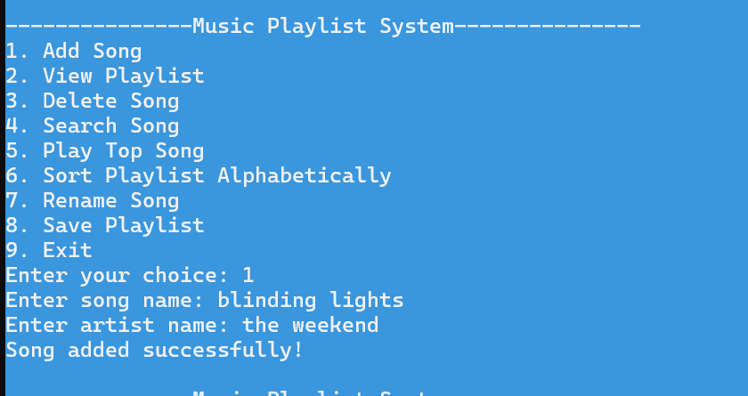

TC2: Add Song — Second Song (Append + Circular Link Update)
Input: Menu choice 1 → Song Name: Tere Bin → Artist: Atif Aslam
Covers:
- if (temp) — TRUE (list has 1 song)
- do-while traversal: checks Song1, no match, temp = temp->next returns to head, loop exits
- if (!head) — FALSE → else branch: tail->next = newSong; newSong->prev = tail; tail = newSong;
- tail->next = head; head->prev = tail; — new circular closure (2-node list)
S# | Statement / Code Line | Description | Covered?
S1 | if (temp) — TRUE | List has 1 existing song | YES — TRUE path
S2 | do { ... } while (temp != head) | Loop entered | YES
S3 | if (temp->name == name && temp->artist == artist) — FALSE | "Tere Bin" ≠ "Blinding Lights" | YES — FALSE path
S4 | temp = temp->next | temp moves back to head (1-node circular) | YES
S5 | while (temp != head) — FALSE | Loop exits after 1 iteration | YES
S6 | Song* newSong = new Song(songIdCounter++, ...) | id = 2 assigned | YES
S7 | if (!head) — FALSE | List not empty | YES — FALSE path
S8 | tail->next = newSong; newSong->prev = tail; tail = newSong; | New node appended after old tail | YES
S9 | tail->next = head; head->prev = tail; | Circular link re-closed (2 nodes) | YES
S10 | cout << "Song added successfully!" | Success message printed | YES

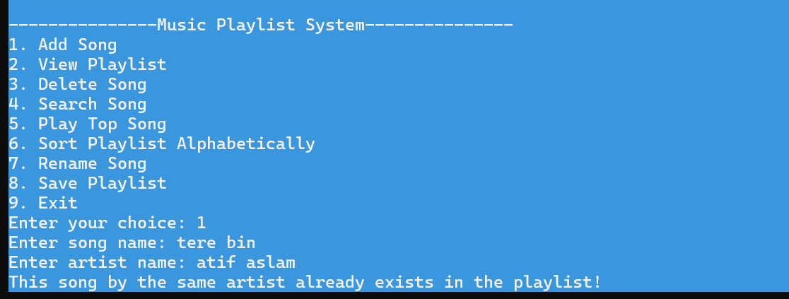

TC3: Add Song — Duplicate Song (Early Return)
Input: Menu choice 1 → Song Name: Blinding Lights → Artist: The Weeknd (same as TC1)
Covers:
- do-while traversal finds match on first iteration
- if (temp->name == name && temp->artist == artist) — TRUE
- cout << "This song by the same artist already exists in the playlist!"
- return; — early exit before new Song is created
S# | Statement / Code Line | Description | Covered?
S1 | if (temp) — TRUE | List has 2 songs | YES
S2 | if (temp->name == name && temp->artist == artist) — TRUE | Matches "Blinding Lights" / "The Weeknd" | YES — TRUE path
S3 | cout << "This song by the same artist already exists in the playlist!" | Duplicate message printed | YES
S4 | return; | Function exits — no new node created | YES

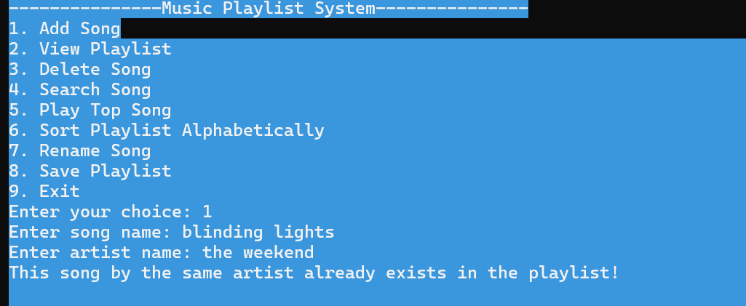

TC4: getValidInput() — Invalid Input Then Valid Input
Input: Menu choice 1 → Song Name: Test@Song (invalid — contains @) → then re-enter: Test Song → Artist: Demo Artist
Covers:
- while (true) outer loop — runs twice
- for (int i = 0; i < input.size(); ++i) — iterates over characters
- if (!isalnum(ch) && ch != ' ' && ...) — TRUE when @ is found
- isValid = false; break; — inner for-loop break
- if (!input.empty() && isValid) — FALSE on first pass, TRUE on second pass
- cout << "Invalid input! Please use only letters, numbers, spaces, or basic punctuation."
- break; exits outer while(true) on valid input
S# | Statement / Code Line | Description | Covered?
S1 | while (true) — iteration 1 | First pass begins | YES
S2 | getline(cin, input) | Reads "Test@Song" | YES
S3 | for (int i = 0; i < input.size(); ++i) | Loop scans each character | YES
S4 | if (!isalnum(ch) && ch != ' ' && ...) — TRUE at @ | Invalid character detected | YES — TRUE path
S5 | isValid = false; break; | Inner for-loop terminated early | YES
S6 | if (!input.empty() && isValid) — FALSE | isValid is false → condition fails | YES — FALSE path
S7 | cout << "Invalid input! ..." | Error message shown | YES
S8 | while (true) — iteration 2 | Second pass begins | YES
S9 | getline(cin, input) | Reads "Test Song" | YES
S10 | for loop completes without break | All characters valid | YES
S11 | if (!input.empty() && isValid) — TRUE | Both conditions true | YES — TRUE path
S12 | break; | Exits outer while loop | YES
S13 | return input; | Returns "Test Song" | YES

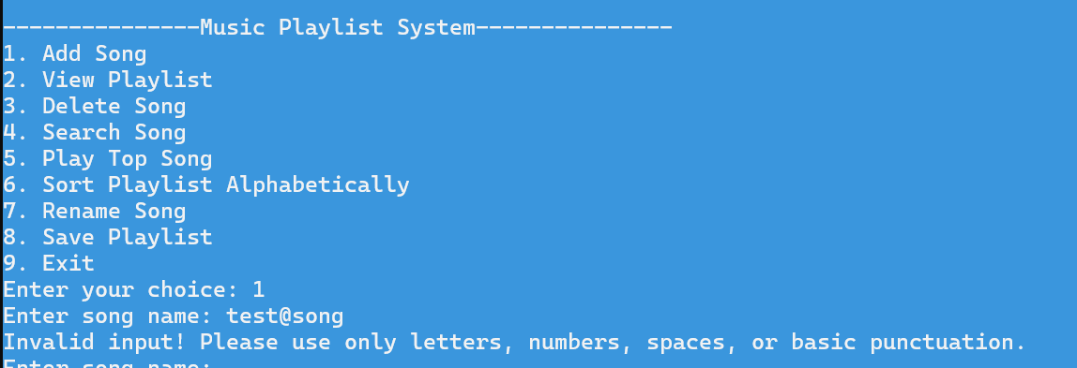

TC5: View Playlist — Empty List
Input: Run a fresh instance of the program (delete playlist.txt if it exists, OR run before adding any songs) → Menu choice 2
Covers:
- if (!head) — TRUE
- cout << "Playlist is empty!"
- return; — early exit before traversal
S# | Statement / Code Line | Description | Covered?
S1 | if (!head) — TRUE | head is NULL (no songs added) | YES — TRUE path
S2 | cout << "Playlist is empty!" | Empty message printed | YES
S3 | return; | Function exits early | YES

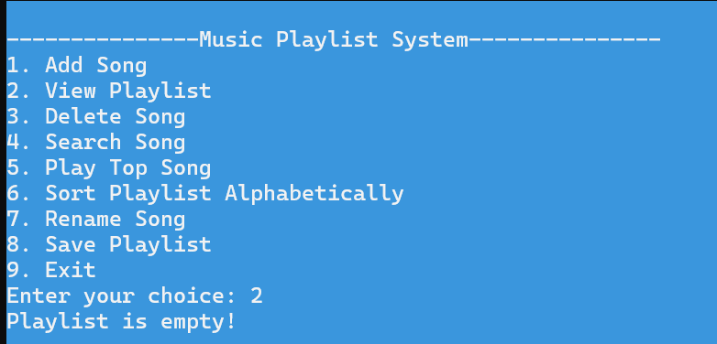

TC6: View Playlist — Non-Empty List (2 Songs from TC1/TC2)
Input: Menu choice 2 (with "Blinding Lights"/"The Weeknd" and "Tere Bin"/"Atif Aslam" in the list)
Covers:
- if (!head) — FALSE
- Song* temp = head assignment
- cout << "\nPlaylist:\n" header
- do-while loop body: cout << "ID: " ... << "Song: " ... << "Artist: "
- temp = temp->next traversal
- while (temp != head) — loop runs twice and exits
S# | Statement / Code Line | Description | Covered?
S1 | if (!head) — FALSE | List has songs | YES — FALSE path
S2 | Song* temp = head | temp initialized to head | YES
S3 | cout << "\nPlaylist:\n" | Header printed | YES
S4 | cout << "ID: " << temp->id << " | Song: " << temp->name << " | Artist: " << temp->artist | Each song's details printed | YES
S5 | temp = temp->next | Pointer advances | YES
S6 | while (temp != head) | Loop repeats for 2nd song, exits after | YES

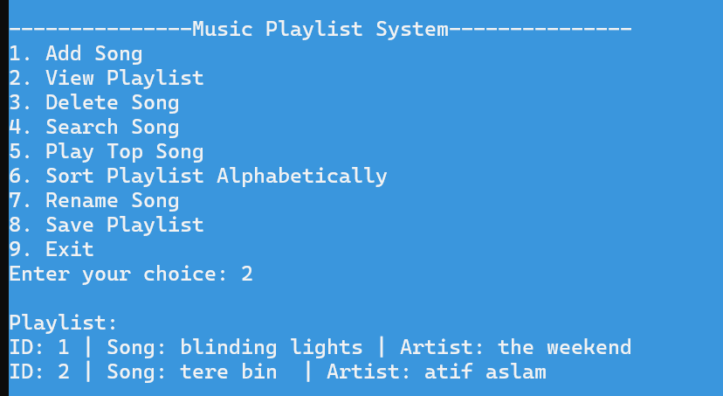

TC7: Delete Song — Only Node in the List (head == tail)
Input: Run a fresh playlist with only 1 song: Add Pasoori / Ali Sethi (choice 1), then delete it (choice 3 → Song Name: Pasoori → Artist: Ali Sethi)
Covers:
- if (!head) — FALSE (1 song exists)
- do-while traversal — match found on first iteration
- if (temp->name == name && temp->artist == artist) — TRUE
- if (temp == head && temp == tail) — TRUE (only node)
- head = tail = NULL;
- delete temp;
- cout << "Song deleted successfully!"
S# | Statement / Code Line | Description | Covered?
S1 | if (!head) — FALSE | List has 1 song | YES — FALSE path
S2 | string name = getValidInput(...) / artist = getValidInput(...) | Reads "Pasoori" / "Ali Sethi" | YES
S3 | do { ... } while (temp != head) | Loop entered | YES
S4 | if (temp->name == name && temp->artist == artist) — TRUE | Match found immediately | YES — TRUE path
S5 | if (temp == head && temp == tail) — TRUE | Only node — both pointers equal | YES — TRUE path
S6 | head = tail = NULL; | List emptied | YES
S7 | delete temp; | Memory freed | YES
S8 | cout << "Song deleted successfully!" | Success message | YES
S9 | return; | Function exits | YES

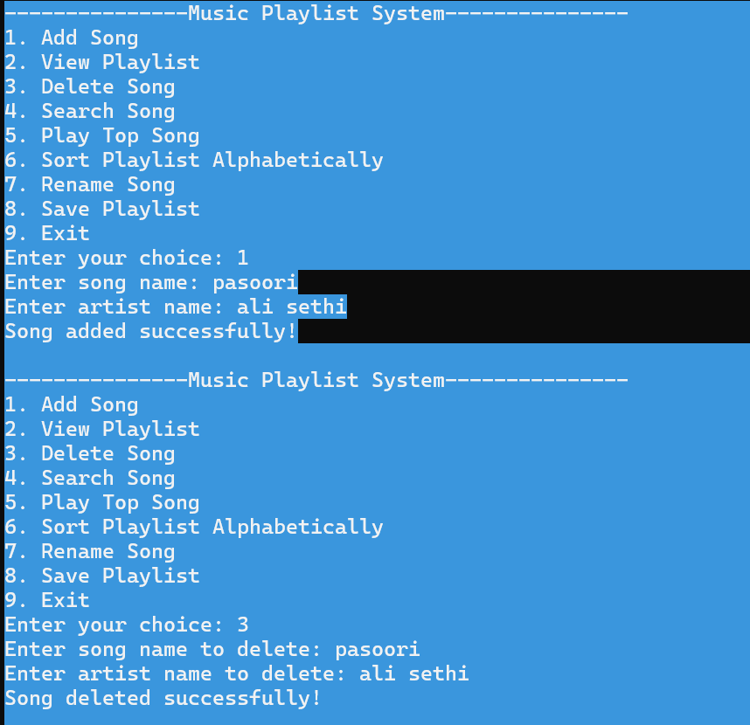

TC8: Delete Song — Head Node (3-Song List)
Setup Input: Add 3 songs in this order:
- Jhol / Maanu
- Kahani Suno / Kaifi Khalil
- Pehchaana / Asim Azhar
Then: Menu choice 3 → Song Name: Jhol → Artist: Maanu (this is the head)
Covers:
- if (temp == head && temp == tail) — FALSE (3 nodes, not equal)
- else if (temp == head) — TRUE
- head = head->next; head->prev = tail; tail->next = head;
S# | Statement / Code Line | Description | Covered?
S1 | if (temp == head && temp == tail) — FALSE | head ≠ tail in a 3-node list | YES — FALSE path
S2 | else if (temp == head) — TRUE | Deleting "Jhol", which is current head | YES — TRUE path
S3 | head = head->next; | head moves to "Kahani Suno" | YES
S4 | head->prev = tail; | New head's prev points to tail | YES
S5 | tail->next = head; | tail's next re-linked to new head | YES
S6 | delete temp; | Old head node deleted | YES
S7 | cout << "Song deleted successfully!" | Success message | YES
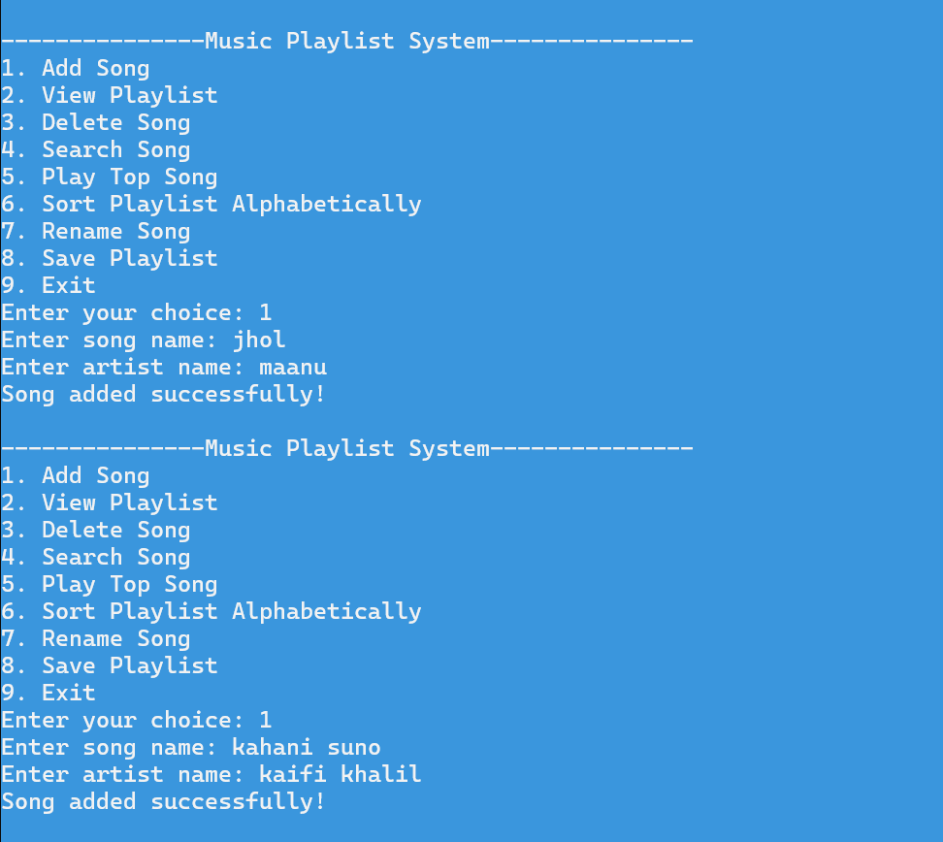
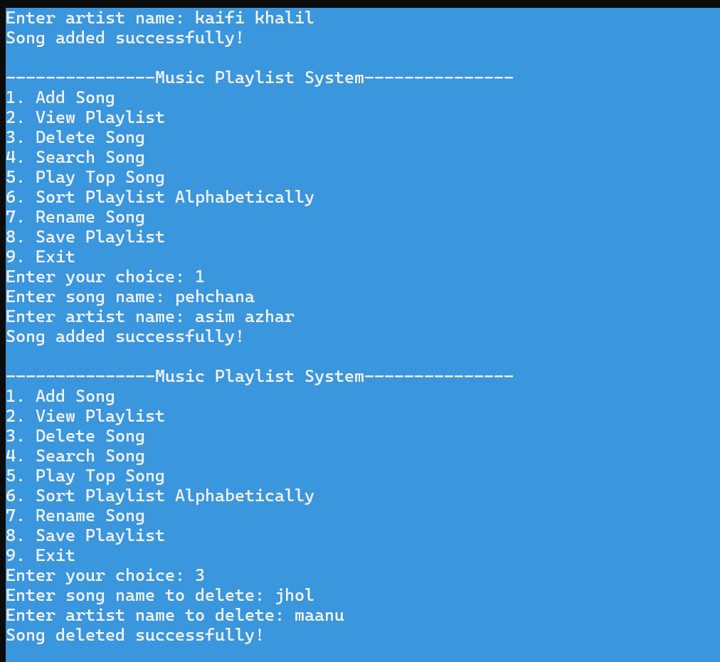

TC9: Delete Song — Tail Node
Input (continuing from TC8, now 2 songs remain — "Kahani Suno" and "Pehchaana"): Menu choice 3 → Song Name: Pehchaana → Artist: Asim Azhar (this is the tail)
Covers:
- else if (temp == head) — FALSE (it's the tail, not head)
- else if (temp == tail) — TRUE
- tail = tail->prev; tail->next = head; head->prev = tail;
S# | Statement / Code Line | Description | Covered?
S1 | else if (temp == head) — FALSE | "Pehchaana" is not the head | YES — FALSE path
S2 | else if (temp == tail) — TRUE | "Pehchaana" is the current tail | YES — TRUE path
S3 | tail = tail->prev; | tail moves back to "Kahani Suno" | YES
S4 | tail->next = head; | New tail's next points to head | YES
S5 | head->prev = tail; | head's prev updated to new tail | YES
S6 | delete temp; | Old tail node deleted | YES
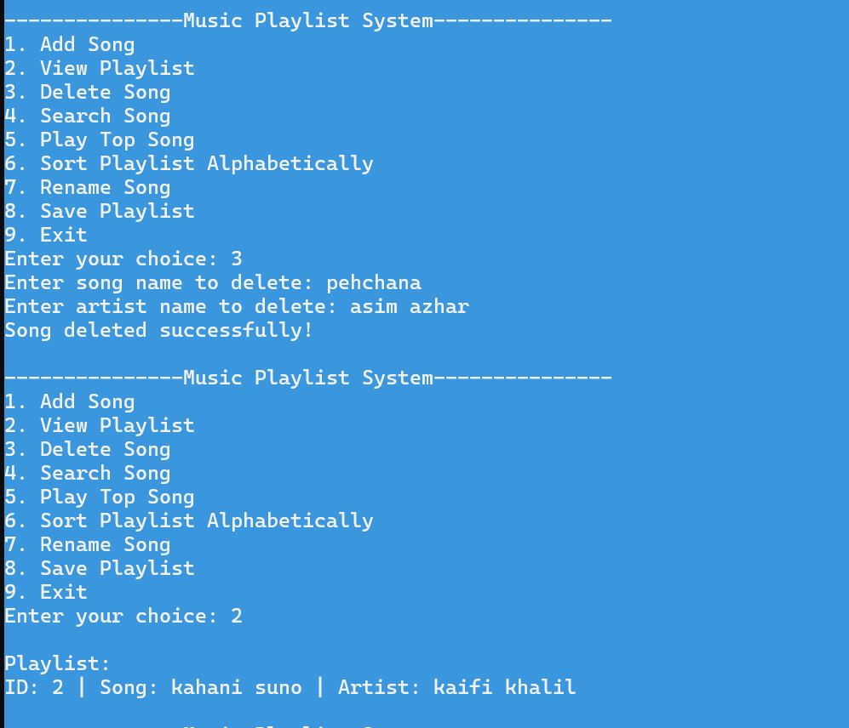

TC10: Delete Song — Middle Node
Setup: Add 3 fresh songs (after TC9, list is empty or has 1 song — add until you have exactly 3):
- Afsanay / Abdul Hannan
- Husn / Anuv Jain
- Khairiyat / Arijit Singh
Then: Menu choice 3 → Song Name: Husn → Artist: Anuv Jain (this is the middle node)
Covers:
- else if (temp == head) — FALSE
- else if (temp == tail) — FALSE
- else branch (middle node): temp->prev->next = temp->next; temp->next->prev = temp->prev;
S# | Statement / Code Line | Description | Covered?
S1 | else if (temp == head) — FALSE | "Husn" is not head | YES — FALSE path
S2 | else if (temp == tail) — FALSE | "Husn" is not tail | YES — FALSE path
S3 | else { temp->prev->next = temp->next; temp->next->prev = temp->prev; } | Middle node bypassed via pointer relinking | YES
S4 | delete temp; | "Husn" node deleted | YES
S5 | cout << "Song deleted successfully!" | Success message | YES
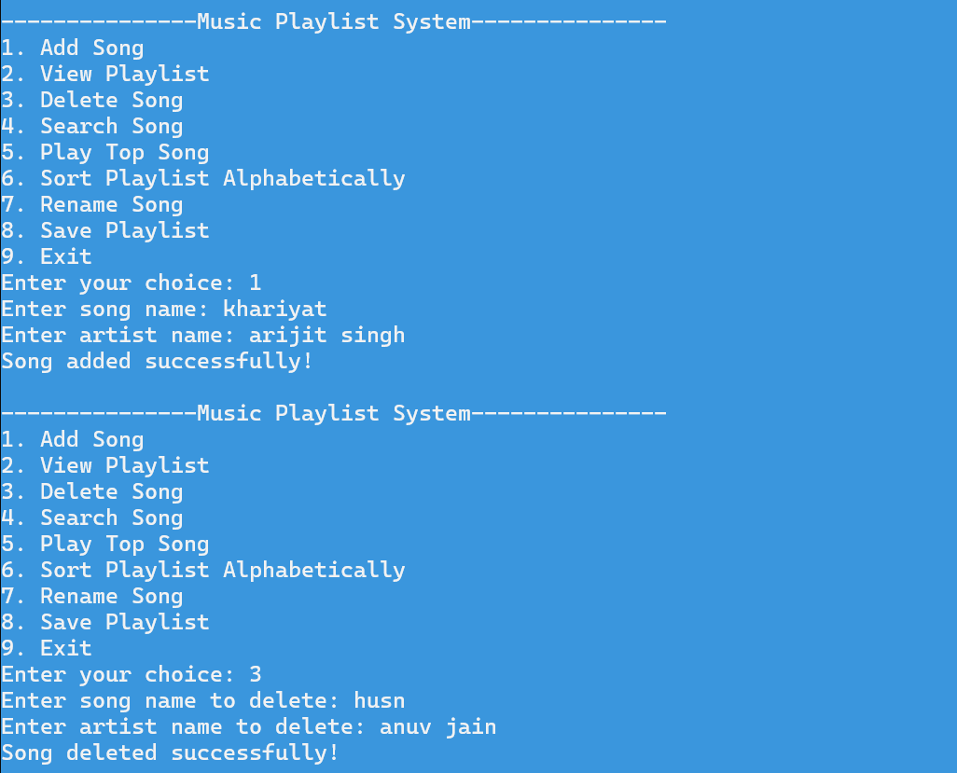
TC11: Delete Song — Song Not Found
Input: Menu choice 3 → Song Name: Nonexistent Song → Artist: Nobody
Covers:
- do-while traverses entire list, no match found
- while (temp != head) — exits after full loop
- cout << "Song not found!" (statement after the loop)
S# | Statement / Code Line | Description | Covered?
S1 | do { if(...) {...} temp = temp->next; } while (temp != head) | Full traversal, no match | YES
S2 | if (temp->name == name && temp->artist == artist) — FALSE (every iteration) | No song matches | YES — FALSE path (all iterations)
S3 | cout << "Song not found!" | Printed after loop completes | YES
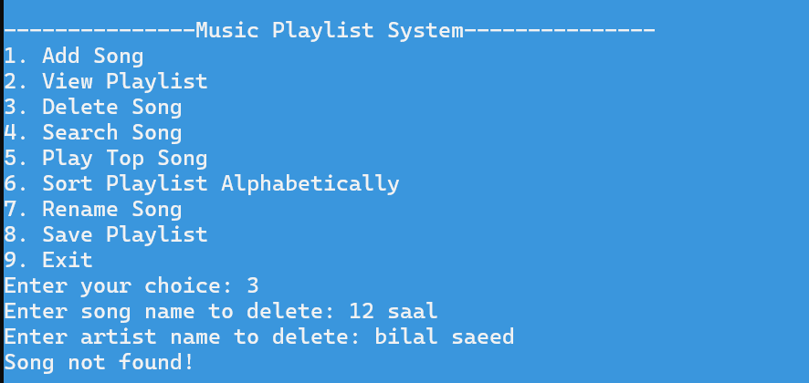

TC12: Search Song — Found and Not Found
Input Part A: Menu choice 4 → Song Name: Afsanay → Artist: Abdul rehman(exists)
Input Part B: Menu choice 4 → Song Name: Random Track → Artist: Unknown (does not exist)
Covers:
- if (!head) — FALSE
- do-while traversal — match found (Part A) and full traversal no match (Part B)
- if (temp->name == name && temp->artist == artist) — TRUE (Part A)
- cout << "Song found: " ... and return;
- cout << "Song not found!" (Part B)
S# | Statement / Code Line | Description | Covered?
S1 | if (!head) — FALSE | List not empty | YES — FALSE path
S2 | if (temp->name == name && temp->artist == artist) — TRUE (Part A) | "Afsanay"/"Abdul Hannan" matches | YES — TRUE path
S3 | cout << "Song found: " << temp->name << " | Artist: " << temp->artist | Found message printed | YES
S4 | return; (Part A) | Exits after finding match | YES
S5 | if (temp->name == name && temp->artist == artist) — FALSE (all iterations, Part B) | No match for "Random Track" | YES — FALSE path
S6 | cout << "Song not found!" (Part B) | Not-found message after loop | YES
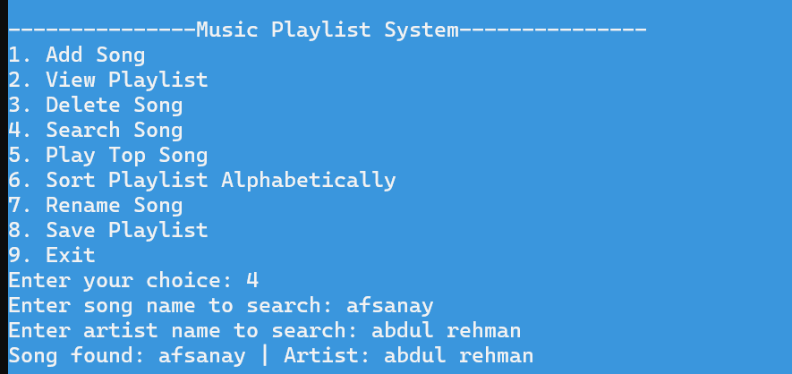


TC13: Play Top Song / Next Song / Previous Song
Input:
- Part A: Menu choice 5 → plays the top song (sets current = head) → then sub-menu choice 1 (Play Next)
- Part B: From sub-menu, choice 2 (Play Previous) twice in a row
- Part C: Sub-menu choice 3 (Return to Main Menu)
Covers:
- playTopSong(): if (!head) — FALSE; current = head; assignment; cout << "Now playing: ..."
- playNextSong(): if (!current) — FALSE (current was set in Part A); current = current->next;
- playPreviousSong(): if (!current) — FALSE; current = current->prev;
S# | Statement / Code Line | Description | Covered?
S1 | if (!head) in playTopSong() — FALSE | List not empty | YES — FALSE path
S2 | current = head; | current pointer initialized | YES
S3 | cout << "Now playing: " << current->name << " by " << current->artist | Top song printed | YES
S4 | if (!current) in playNextSong() — FALSE | current is set | YES — FALSE path
S5 | current = current->next; | Moves to next song in circular list | YES
S6 | if (!current) in playPreviousSong() — FALSE | current is set | YES — FALSE path
S7 | current = current->prev; | Moves to previous song | YES
S8 | cout << "Returning to main menu..." (choice 3 in sub-menu) | Returns to main menu | YES
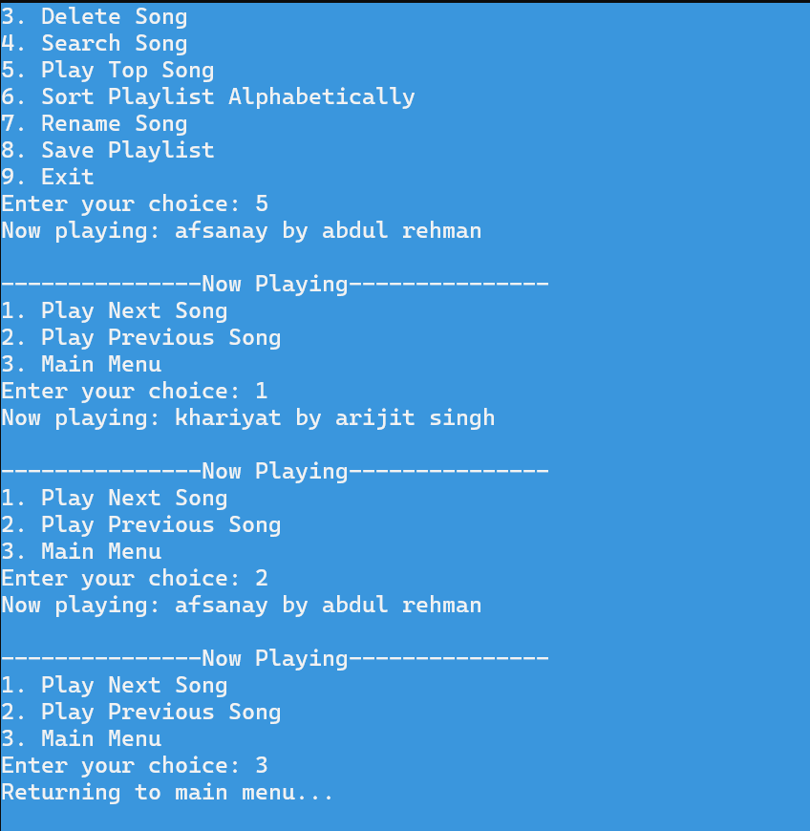

TC14: Rename Song — Success, Duplicate New Name, and Not Found
Input Part A (Success): Menu choice 7 → Old Name: Khairiyat → Old Artist: Arijit Singh → New Name: Khairiyat Acoustic → New Artist: Arijit Singh
Input Part B (Duplicate new name): Menu choice 7 → Old Name: Afsanay → Old Artist: Abdul Hannan → New Name: Khairiyat Acoustic (already exists from Part A) → New Artist: Test Artist
Input Part C (Not found): Menu choice 7 → Old Name: Nonexistent → Old Artist: Nobody
Covers:
- if (!head) — FALSE
- do-while traversal — match found (Parts A, B), full traversal no match (Part C)
- if (temp->name == oldName && temp->artist == oldArtist) — TRUE (A, B), FALSE all iterations (C)
- if (songExists(newName)) — FALSE (A), TRUE (B)
- temp->name = newName; temp->artist = newArtist; (A only)
- cout << "Song renamed successfully!" (A)
- cout << "A song with the new name already exists in the playlist!" (B)
- cout << "Song not found!" (C)
S# | Statement / Code Line | Description | Covered?
S1 | if (!head) — FALSE | List not empty | YES — FALSE path
S2 | if (temp->name == oldName && temp->artist == oldArtist) — TRUE (A) | "Khairiyat"/"Arijit Singh" found | YES — TRUE path
S3 | string newName = getValidInput(...), newArtist = getValidInput(...) | Reads new name/artist | YES
S4 | if (songExists(newName)) — FALSE (A) | "Khairiyat Acoustic" doesn't exist yet | YES — FALSE path
S5 | temp->name = newName; temp->artist = newArtist; | Song fields updated | YES
S6 | cout << "Song renamed successfully!" | Success message (A) | YES
S7 | if (temp->name == oldName && temp->artist == oldArtist) — TRUE (B) | "Afsanay"/"Abdul Hannan" found | YES
S8 | if (songExists(newName)) — TRUE (B) | "Khairiyat Acoustic" now exists (from A) | YES — TRUE path
S9 | cout << "A song with the new name already exists in the playlist!" | Duplicate-rename blocked (B) | YES
S10 | return; (inside songExists TRUE block) | Function exits without renaming | YES
S11 | if (temp->name == oldName && temp->artist == oldArtist) — FALSE (all iterations, C) | "Nonexistent" not in list | YES — FALSE path
S12 | cout << "Song not found!" (C) | Not-found message after loop | YES

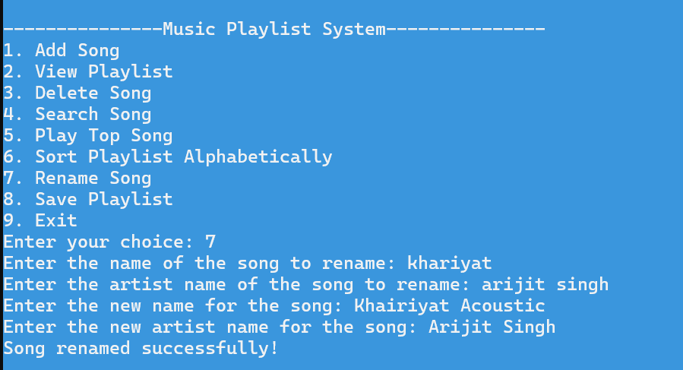
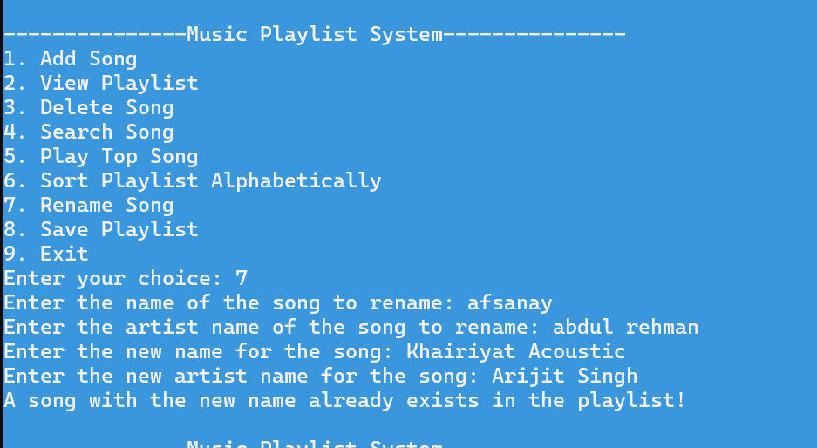


TC15: Sort Playlist — Empty/Single Song & Multiple Songs
Input Part A: Start a fresh playlist with 0 or 1 song → Menu choice 6
Input Part B: Add 3 unsorted songs:
- Afsanay / Abdul rehman
- khariyat / arjit singh
Then choice 6 (Sort)
Covers:
- if (!head || !head->next) — TRUE (Part A, 0 or 1 song)
- cout << "Playlist is already sorted or empty!"
- if (!head || !head->next) — FALSE (Part B, 3 songs)
- Outer while (current != tail) loop
- Inner while (temp != head) loop
- if (temp->name < min->name) — TRUE/FALSE comparisons
- if (min != current) — TRUE (swap occurs) / FALSE (already in place)
- swap(current->name, min->name); swap(current->artist, min->artist);
- cout << "Playlist sorted successfully!"
S# | Statement / Code Line | Description | Covered?
S1 | if (!head || !head->next) — TRUE (A) | List empty or has 1 song | YES — TRUE path
S2 | cout << "Playlist is already sorted or empty!" | Message printed (A) | YES
S3 | return; (A) | Early exit | YES
S4 | if (!head || !head->next) — FALSE (B) | List has 3 songs | YES — FALSE path
S5 | Song* current = head; while (current != tail) | Outer selection-sort loop begins | YES
S6 | Song* min = current; Song* temp = current->next; | Pointers initialized | YES
S7 | while (temp != head) inner loop | Scans remaining nodes for minimum | YES
S8 | if (temp->name < min->name) — TRUE (at least once) | A smaller name found, min updated | YES — TRUE path
S9 | if (temp->name < min->name) — FALSE (at least once) | Current min remains smallest | YES — FALSE path
S10 | if (min != current) — TRUE | Swap needed | YES — TRUE path
S11 | swap(current->name, min->name); swap(current->artist, min->artist); | Song data swapped | YES
S12 | current = current->next; | Outer loop advances | YES
S13 | cout << "Playlist sorted successfully!" | Success message after sort | YES
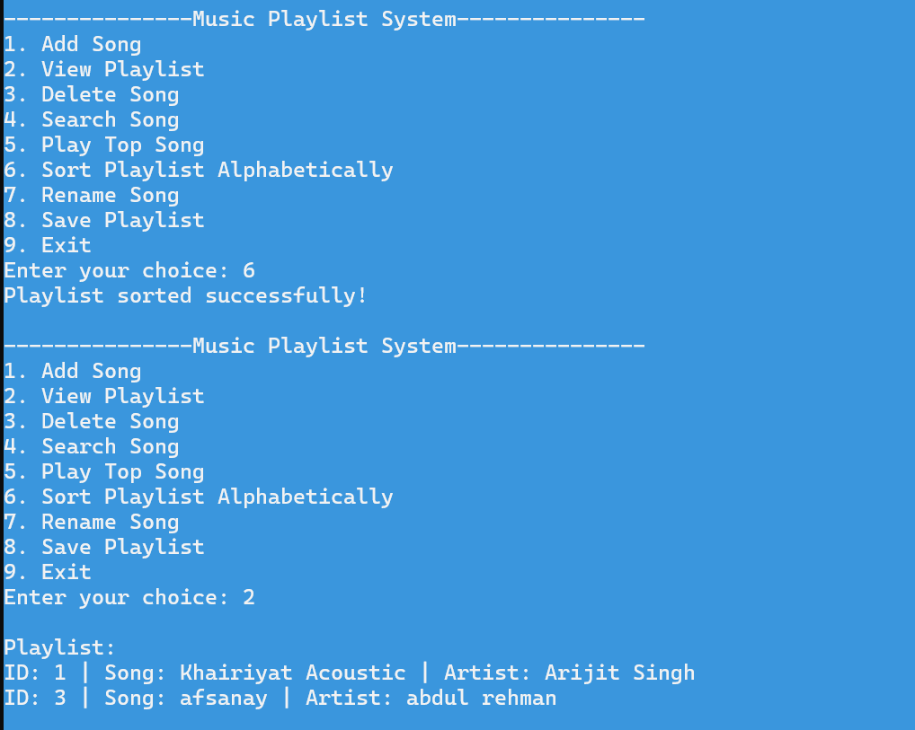

2. Branch Coverage
Branch Coverage ensures every TRUE and FALSE outcome of every decision point is exercised.

Function: songExists()
Branch 1 — Empty List Check: if (!temp)
TC ID | Input | Condition Result | Expected Output | Branch
BC-01 | Called on empty playlist | TRUE | Returns false immediately | TRUE branch
BC-02 | Called on non-empty playlist | FALSE | Proceeds to do-while search | FALSE branch




Branch 2 — Name Match: if (temp->name == name)
TC ID | Input | Condition Result | Expected Output | Branch
BC-03 | Search for a name that exists | TRUE | Returns true | TRUE branch
BC-04 | Search for a name that doesn't exist | FALSE (all iterations) | Returns false after full loop | FALSE branch
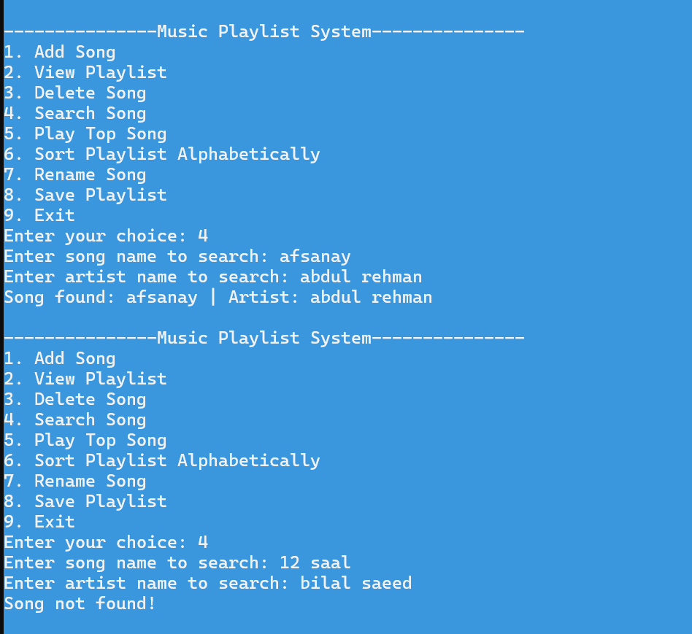

Function: getValidInput()
Branch 1 — Invalid Character Check: if (!isalnum(ch) && ch != ' ' && ... )
TC ID | Input | Condition Result | Expected Output | Branch
BC-05 | Character @ in input | TRUE | isValid = false; break; | TRUE branch
BC-06 | All characters are letters/digits/spaces | FALSE (every char) | isValid remains true | FALSE branch


Branch 2 — Valid Input Check: if (!input.empty() && isValid)
TC ID | Input | Condition Result | Expected Output | Branch
BC-07 | Test@Song (invalid char present) | FALSE | "Invalid input!" message; loop repeats | FALSE branch
BC-08 | Test Song (valid) | TRUE | break; — returns input | TRUE branch
BC-09 | Empty input (press Enter only) | FALSE (input.empty() is TRUE) | "Invalid input!" message; loop repeats | FALSE branch
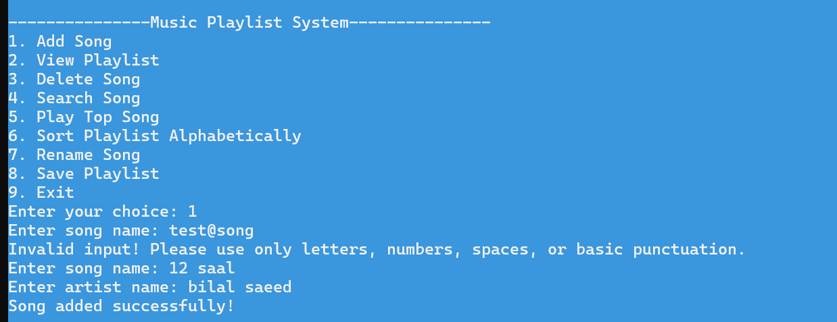

Function: loadFromFile()
Branch 1 — File Exists Check: if (!inFile)
TC ID | Input | Condition Result | Expected Output | Branch
BC-10 | playlist.txt does not exist (first run) | TRUE | Function returns immediately; playlist starts empty | TRUE branch
BC-11 | playlist.txt exists with saved data | FALSE | Proceeds to read loop | FALSE branch

Branch 2 — Read Loop: while (getline(inFile, line))
TC ID | Input | Condition Result | Expected Output | Branch
BC-12 | File has 3 valid records | TRUE (3 times), then FALSE | Reads 3 songs, loop ends at EOF | Both branches
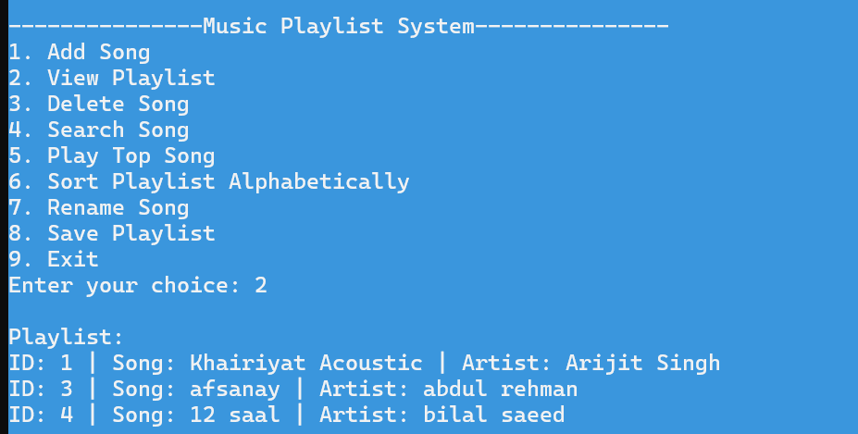

Branch 3 — Record Completeness: if (!getline(inFile, name) || !getline(inFile, artist))
TC ID | Input | Condition Result | Expected Output | Branch
BC-13 | Normal 3-line record (id, name, artist) | FALSE | Record loaded normally | FALSE branch
BC-14 | Malformed file (id with missing name/artist line) | TRUE | break; — loop exits early | TRUE branch



Branch 4 — First Node Check: if (!head)
TC ID | Input | Condition Result | Expected Output | Branch
BC-15 | First record being loaded | TRUE | head = tail = newSong | TRUE branch
BC-16 | Second/third record being loaded | FALSE | Appended via tail->next = newSong | FALSE branch



Branch 1 — Duplicate Check Entry: if (temp)
TC ID | Input | Condition Result | Expected Output | Branch
BC-17 | Adding first song (empty list) | FALSE | Duplicate-check loop skipped | FALSE branch
BC-18 | Adding song to non-empty list | TRUE | Duplicate-check loop runs | TRUE branch

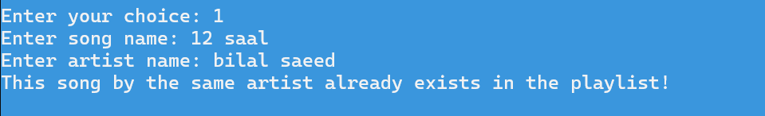

Branch 2 — Duplicate Match: if (temp->name == name && temp->artist == artist)
TC ID | Input | Condition Result | Expected Output | Branch
BC-19 | New unique song | FALSE | Song added normally | FALSE branch
BC-20 | Exact duplicate (same name + artist) | TRUE | "This song by the same artist already exists!" | TRUE branch



Function: viewPlaylist()
Branch — Empty Check: if (!head)
TC ID | Input | Condition Result | Expected Output | Branch
BC-23 | Empty playlist | TRUE | "Playlist is empty!" | TRUE branch
BC-24 | Non-empty playlist | FALSE | All songs listed | FALSE branch



Function: deleteSong()
Branch 1 — Empty Check: if (!head)
TC ID | Input | Condition Result | Expected Output | Branch
BC-25 | Delete on empty playlist | TRUE | "Playlist is empty!" | TRUE branch
BC-26 | Delete on non-empty playlist | FALSE | Proceeds to search | FALSE branch
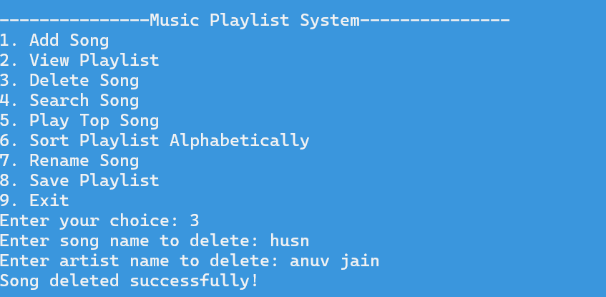

Branch 2 — Match Found: if (temp->name == name && temp->artist == artist)

TC ID | Input | Condition Result | Expected Output | Branch
BC-27 | Song exists in list | TRUE | Node removed; "Song deleted successfully!" | TRUE branch
BC-28 | Song not in list | FALSE (all iterations) | "Song not found!" | FALSE branch

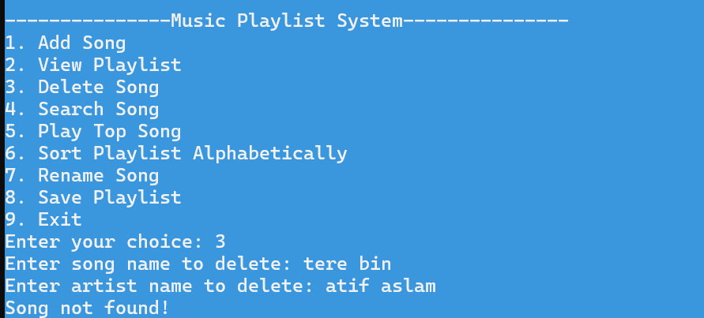


Function: searchSong()
TC ID | Input | Condition Result | Expected Output | Branch
BC-35 | Search on empty playlist | if (!head) TRUE | "Playlist is empty!" | TRUE branch
BC-36 | Search for existing song | if (temp->name==name && temp->artist==artist) TRUE | "Song found: ..." | TRUE branch
BC-37 | Search for non-existent song | Same condition FALSE (all) | "Song not found!" | FALSE branch

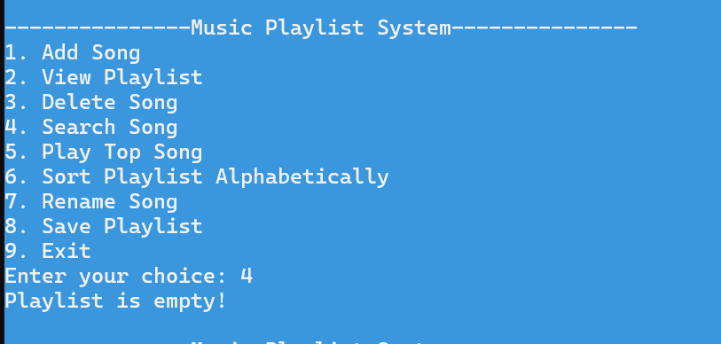

Functions: playNextSong() / playPreviousSong()

Branch — Current Song Set: if (!current)
TC ID | Input | Condition Result | Expected Output | Branch
BC-38 | Choice 5 not yet selected (current = NULL), then somehow reach Next/Previous | TRUE | "No song is currently playing." | TRUE branch
BC-39 | Choice 5 selected first (current is set) | FALSE | current = current->next/prev; song printed | FALSE branch

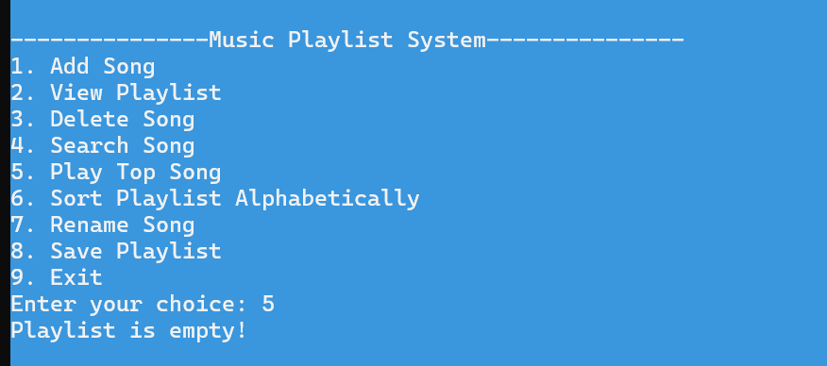



Function: renameSong()
TC ID | Input | Condition Result | Expected Output | Branch
BC-40 | Rename on empty playlist | if (!head) TRUE | "Playlist is empty!" | TRUE branch
BC-41 | Old song found | if (temp->name==oldName && temp->artist==oldArtist) TRUE | Proceeds to new-name input | TRUE branch
BC-42 | Old song not found | Same condition FALSE (all) | "Song not found!" | FALSE branch
BC-43 | New name doesn't already exist | if (songExists(newName)) FALSE | Rename completes | FALSE branch
BC-44 | New name already exists | if (songExists(newName)) TRUE | "A song with the new name already exists!" | TRUE branch

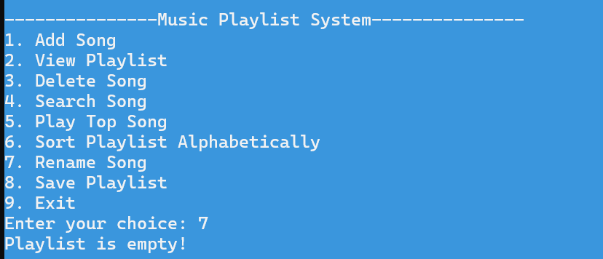



Function: sortPlaylist()
TC ID | Input | Condition Result | Expected Output | Branch
BC-45 | 0 or 1 song | if (!head || !head->next) TRUE | "Playlist is already sorted or empty!" | TRUE branch
BC-46 | 2+ songs, unsorted | Same condition FALSE | Selection sort runs | FALSE branch
BC-47 | Within sort: a smaller name found | if (temp->name < min->name) TRUE | min = temp | TRUE branch
BC-48 | Within sort: current name already smallest | Same condition FALSE | min unchanged | FALSE branch
BC-49 | min differs from current | if (min != current) TRUE | Swap performed | TRUE branch
BC-50 | min equals current (already in correct position) | Same condition FALSE | No swap | FALSE branch


3. Condition Coverage
Condition Coverage tests each individual sub-condition inside compound boolean expressions independently as TRUE and FALSE.

Function: addSong() / deleteSong() / searchSong() / renameSong() — Name+Artist Match
Condition: temp->name == name && temp->artist == artist (or oldName/oldArtist in renameSong)
TC ID | Sub-Condition A name matches | Sub-Condition B artist matches | Input Scenario | Overall Result
CC-01 | TRUE | TRUE | Exact match (e.g., "Pasoori"/"Ali Sethi" both correct) | TRUE — match found
CC-02 | TRUE | FALSE | Same song name, different artist (e.g., "Pasoori" / "Wrong Artist") | FALSE — not a match
CC-03 | FALSE | TRUE | Different song name, same artist (e.g., "Wrong Song" / "Ali Sethi") | FALSE — not a match
CC-04 | FALSE | FALSE | Completely different song | FALSE — not a match

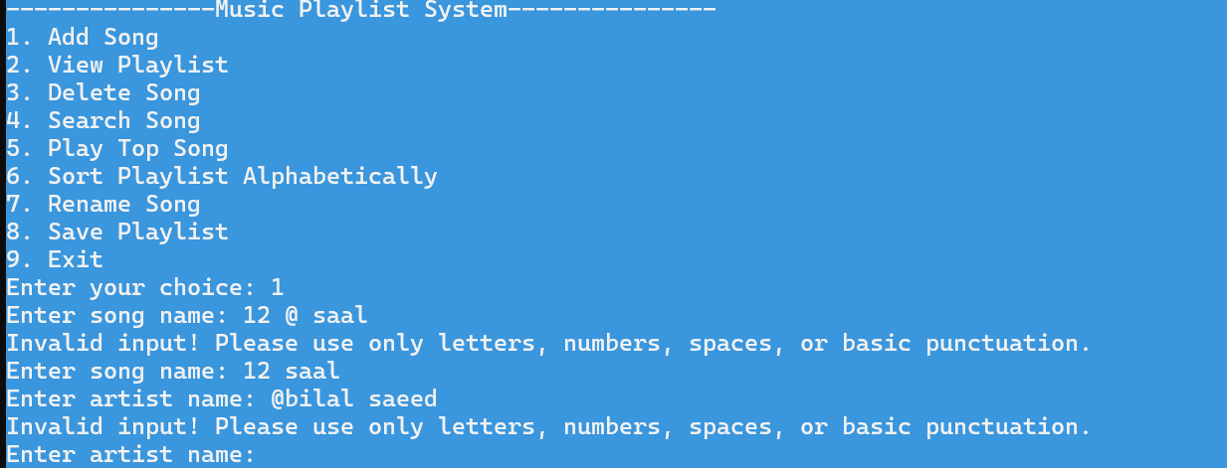

Function: deleteSong() — Single Node Check
Condition: temp == head && temp == tail
TC ID | Sub-Condition A temp == head | Sub-Condition B temp == tail | Input Scenario | Overall Result
CC-05 | TRUE | TRUE | List has exactly 1 song, deleting it | TRUE — head = tail = NULL
CC-06 | TRUE | FALSE | List has 2+ songs, deleting the head | FALSE — falls to else if (temp == head)
CC-07 | FALSE | TRUE | List has 2+ songs, deleting the tail | FALSE — falls to else if (temp == tail)
CC-08 | FALSE | FALSE | List has 3+ songs, deleting a middle node | FALSE — falls to else (middle relink)




Function: sortPlaylist() — Empty/Single Check
Condition: !head || !head->next
TC ID | Sub-Condition A !head | Sub-Condition B !head->next | Input Scenario | Overall Result
CC-09 | TRUE | (short-circuit, B not evaluated) | Empty playlist (head == NULL) | TRUE — "already sorted or empty"
CC-10 | FALSE | TRUE | Exactly 1 song (head->next points to itself) | TRUE — "already sorted or empty"
CC-11 | FALSE | FALSE | 2+ songs | FALSE — sorting proceeds


Condition: !input.empty() && isValid

TC ID | Sub-Condition A !input.empty() | Sub-Condition B isValid | Input Scenario | Overall Result
CC-12 | TRUE | TRUE | Non-empty, all valid characters (e.g., "Tere Bin") | TRUE — input accepted
CC-13 | TRUE | FALSE | Non-empty but contains invalid char (e.g., "Test@Song") | FALSE — re-prompted
CC-14 | FALSE | TRUE (vacuously) | User presses Enter with no text | FALSE — re-prompted


4. Loop Testing
Loop testing targets the execution boundaries (zero, one, and multiple iterations) of every loop in the system.

Loop 1 — songExists() do-while Traversal
TC ID | Loop Scenario | System State | Iterations | Expected Output
LT-01 | Zero iterations (empty list) | head == NULL | 0 — if (!temp) return false exits before loop | Returns false
LT-02 | Single iteration — match at first node | 1 song in list, that song's name searched | 1 | Returns true
LT-03 | Multiple iterations — match not at head | 3 songs, searching for the 3rd song's name | 3 | Returns true after full traversal

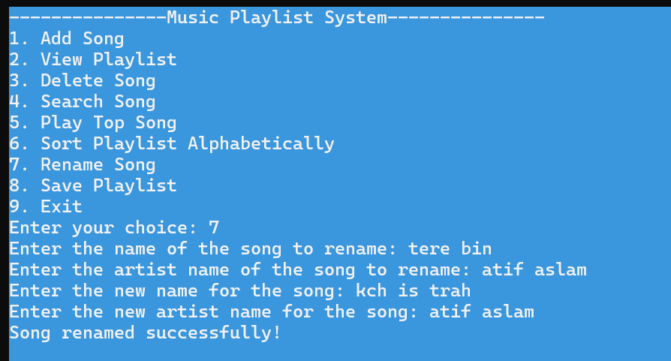

Loop 2 — getValidInput() Outer while(true) and Inner for Loop
TC ID | Loop Scenario | Input | Iterations | Expected Output
LT-05 | Outer loop: 2 iterations (invalid then valid) | "Test@Song" then "Test Song" | 2 | Reprompts once before accepting
LT-06 | Inner for loop: zero iterations | Empty string entered (size = 0) | 0 — for loop body never runs | isValid stays true, but !input.empty() is FALSE → rejected
LT-07 | Inner for loop: full string scanned, no early break | "Tere Bin" (8 chars, all valid) | 8 | Loop completes naturally
LT-08 | Inner for loop: early break on invalid char | "Te@st" — breaks at index 2 (@) | 3 (breaks early) | isValid = false



Loop 3 — loadFromFile() while (getline(inFile, line))

TC ID | Loop Scenario | System State | Iterations | Expected Output
LT-09 | Zero iterations | playlist.txt doesn't exist or is empty | 0 | Playlist starts empty
LT-10 | Multiple iterations | playlist.txt has 3 saved songs | 3 | All 3 songs loaded into circular list
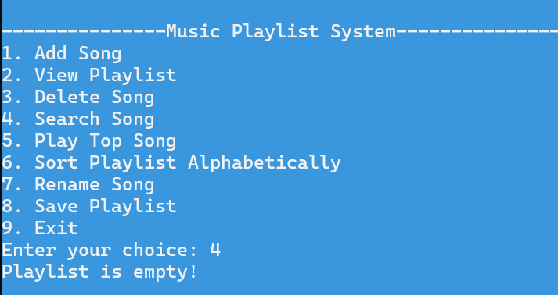

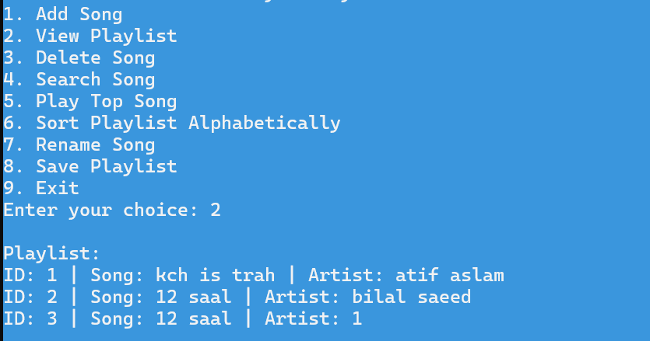

Loop 4 — addSong() / deleteSong() / searchSong() / renameSong() do-while Traversal
TC ID | Function | Loop Scenario | System State | Iterations | Expected Output
LT-11 | addSong (duplicate check) | Single iteration | 1 song in list, checking for duplicate | 1 | Loop exits after checking the 1 song
LT-12 | searchSong | Multiple iterations, match at end | 3 songs, searching for 3rd | 3 | Found on 3rd iteration
LT-13 | deleteSong | Full traversal, no match | 3 songs, deleting non-existent | 3 (full loop) | "Song not found!"
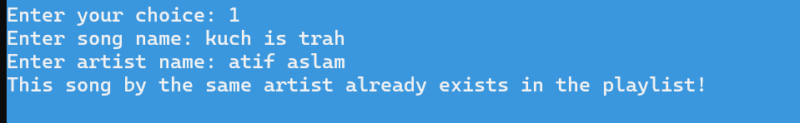
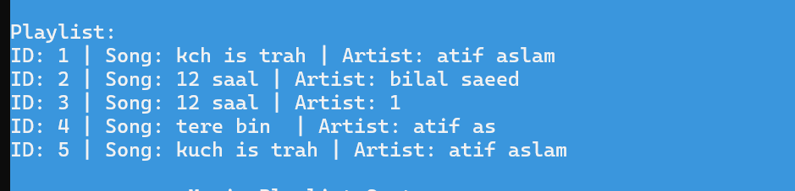

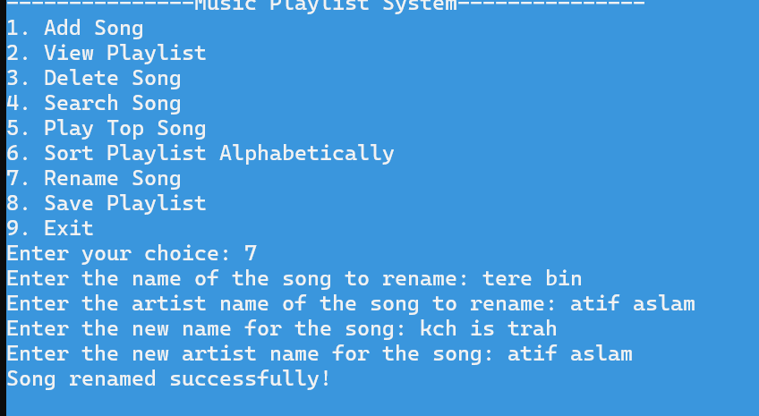

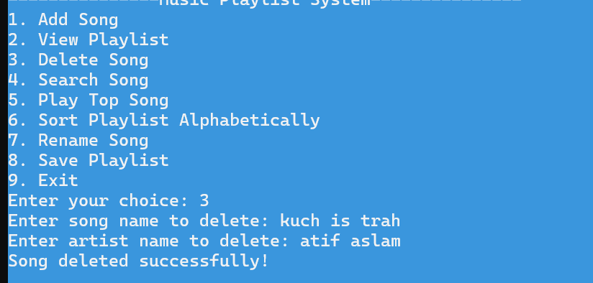

Loop 5 — sortPlaylist() Nested while Loops
TC ID | Loop Scenario | System State | Outer Iterations | Inner Iterations | Expected Output
LT-14 | Outer loop: 2 passes (3-song list) | 2 unsorted songs | 2 (current advances until it equals tail) | 2 then 1 | Full selection sort completes
LT-15 | Inner loop: scans remaining nodes each pass | Same 3-song list | — | Pass 1: 2 inner iterations; Pass 2: 1 inner iteration | min correctly identifies smallest remaining name each pass


Loop 6— main() Menu Input Validation Loops
TC ID | Loop Scenario | Input | Iterations | Expected Output
LT-18 | Main menu: valid choice first try | 4 | 0 (loop body never runs) | Proceeds directly to View Playlist
LT-19 | Main menu: invalid choice then valid | 15, then 2 | 1 | "Invalid choice! Please enter a number between 1 and 9:" then proceeds
LT-20 | Sub-menu (Now Playing): invalid then valid | 5, then 1 | 1 | "Invalid choice! Please enter a number between 1 and 3:" then plays next song

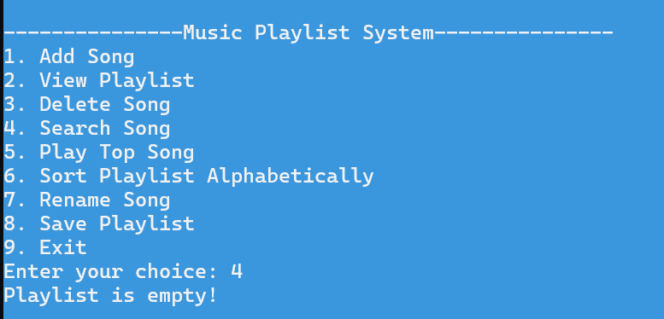
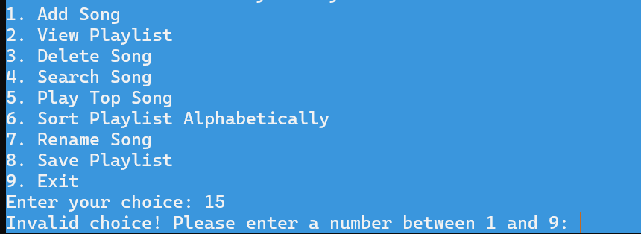
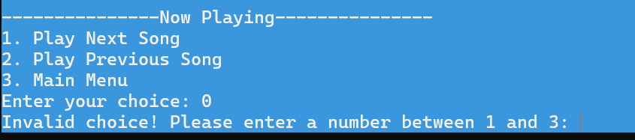

5. Control Flow Testing
Control Flow Testing verifies that all possible execution paths through each function are exercised.

Function: addSong() — Path Analysis
Path ID | Path Description | Input to Trigger | Expected Output
CFT-01 | Empty list → first song added | Any song on a fresh playlist | "Song added successfully!" (head=tail=newSong)
CFT-02 | Non-empty list → unique song → appended | A new unique song, list has 1+ songs | "Song added successfully!" (appended to tail)
CFT-03 | Non-empty list → duplicate found → early return | Re-add an existing song/artist pair | "This song by the same artist already exists in the playlist!"

Function: deleteSong() — Path Analysis
Path ID | Path Description | Input to Trigger | Expected Output
CFT-04 | Empty list → early return | Delete on empty playlist | "Playlist is empty!"
CFT-05 | Song not found → full traversal | Delete a non-existent song | "Song not found!"
CFT-06 | Found → only node → list emptied | Delete the only song in a 1-song list | "Song deleted successfully!" (head=tail=NULL)
CFT-07 | Found → head node (2+ songs) → head advances | Delete current head in a multi-song list | "Song deleted successfully!" (new head set)
CFT-08 | Found → tail node → tail moves back | Delete current tail in a multi-song list | "Song deleted successfully!" (new tail set)
CFT-09 | Found → middle node → pointers relinked | Delete a middle node in a 3+ song list | "Song deleted successfully!" (middle bypassed)

Function: renameSong() — Path Analysis
Path ID | Path Description | Input to Trigger | Expected Output
CFT-10 | Empty list → early return | Rename on empty playlist | "Playlist is empty!"
CFT-11 | Old song not found → full traversal | Rename a non-existent song | "Song not found!"
CFT-12 | Old song found → new name unique → renamed | Valid rename with unique new name | "Song renamed successfully!"
CFT-13 | Old song found → new name already exists → blocked | Rename to a name that already exists | "A song with the new name already exists in the playlist!"

Function: sortPlaylist() — Path Analysis
Path ID | Path Description | Input to Trigger | Expected Output
CFT-14 | Empty or single-song list → early return | Sort with 0 or 1 song | "Playlist is already sorted or empty!"
CFT-15 | Multiple songs → full selection sort executes | 3 unsorted songs | "Playlist sorted successfully!" — playlist now alphabetical

Function: getValidInput() — Path Analysis
Path ID | Path Description | Input to Trigger | Expected Output
CFT-16 | Valid input on first attempt → immediate return | "Pasoori" | Returns "Pasoori" without re-prompt
CFT-17 | Invalid character → reprompt → valid input → return | "Te@st" then "Test" | "Invalid input!..." then returns "Test"
CFT-18 | Empty input → reprompt → valid input → return | Press Enter alone, then "Test" | "Invalid input!..." then returns "Test"

6. Cyclomatic Complexity Analysis
Cyclomatic Complexity (CC) = Number of Decision Points + 1. CC of 1–10 is simple, 11–20 moderate, 21+ complex. Compound conditions (multiple &&/||) are counted as 1 decision point each, consistent with the Music Playlist reference document's convention.

1. songExists()
Decision points:
if (!temp) → 1
while (temp != head) → 1
if (temp->name == name) → 1
CC = 3 + 1 = 4
Decision Point | Condition | Count
Empty list check | !temp | 1
Traversal loop | temp != head | 1
Name match | temp->name == name | 1
Total CC |  | 4

2. getValidInput()
Decision points:
while (true) → 1
for (int i = 0; i < input.size(); ++i) → 1
if (!isalnum(ch) && ch != ' ' && ... ) → 1 (compound = 1)
if (!input.empty() && isValid) → 1 (compound = 1)
CC = 4 + 1 = 5
Decision Point | Condition | Count
Outer retry loop | while (true) | 1
Character scan loop | for loop | 1
Invalid character check | compound && condition | 1
Valid-input check | !input.empty() && isValid | 1
Total CC |  | 5

3. loadFromFile()
Decision points:
if (!inFile) → 1
while (getline(inFile, line)) → 1
if (!getline(name) || !getline(artist)) → 1 (compound = 1)
if (!head) → 1
CC = 4 + 1 = 5
Decision Point | Condition | Count
File-exists check | !inFile | 1
Read loop | getline(inFile, line) | 1
Record-complete check | compound || condition | 1
First-node check | !head | 1
Total CC |  | 5

4. addSong()
Decision points:
if (temp) → 1
while (temp != head) → 1
if (temp->name == name && temp->artist == artist) → 1 (compound = 1)
if (!head) → 1
CC = 4 + 1 = 5
Decision Point | Condition | Count
Duplicate-check entry | temp (non-null) | 1
Traversal loop | temp != head | 1
Duplicate match | compound && condition | 1
First-node insertion | !head | 1
Total CC |  | 5

5. viewPlaylist()
Decision points:
if (!head) → 1
while (temp != head) → 1
CC = 2 + 1 = 3
Decision Point | Condition | Count
Empty list check | !head | 1
Traversal loop | temp != head | 1
Total CC |  | 3

6. deleteSong()
Decision points:
if (!head) → 1
while (temp != head) → 1
if (temp->name == name && temp->artist == artist) → 1 (compound = 1)
if (temp == head && temp == tail) → 1 (compound = 1)
else if (temp == head) → 1
else if (temp == tail) → 1
CC = 6 + 1 = 7
Decision Point | Condition | Count
Empty list check | !head | 1
Traversal loop | temp != head | 1
Song match | compound && condition | 1
Single-node check | compound && condition | 1
Head-node check | temp == head | 1
Tail-node check | temp == tail | 1
Total CC |  | 7

7. searchSong()
Decision points:
if (!head) → 1
while (temp != head) → 1
if (temp->name == name && temp->artist == artist) → 1 (compound = 1)
CC = 3 + 1 = 4
Decision Point | Condition | Count
Empty list check | !head | 1
Traversal loop | temp != head | 1
Song match | compound && condition | 1
Total CC |  | 4

8. playTopSong()
Decision points:
if (!head) → 1
CC = 1 + 1 = 2

9. playNextSong()
Decision points:
if (!current) → 1
CC = 1 + 1 = 2

10. playPreviousSong()
Decision points:
if (!current) → 1
CC = 1 + 1 = 2

11. renameSong()
Decision points:
if (!head) → 1
while (temp != head) → 1
if (temp->name == oldName && temp->artist == oldArtist) → 1 (compound = 1)
if (songExists(newName)) → 1
CC = 4 + 1 = 5
Decision Point | Condition | Count
Empty list check | !head | 1
Traversal loop | temp != head | 1
Old song match | compound && condition | 1
New-name duplicate check | songExists(newName) | 1
Total CC |  | 5

12. sortPlaylist()
Decision points:
if (!head || !head->next) → 1 (compound = 1)
while (current != tail) → 1
while (temp != head) → 1
if (temp->name < min->name) → 1
if (min != current) → 1
CC = 5 + 1 = 6
Decision Point | Condition | Count
Empty/single check | compound || condition | 1
Outer selection loop | current != tail | 1
Inner scan loop | temp != head | 1
Minimum comparison | temp->name < min->name | 1
Swap check | min != current | 1
Total CC |  | 6

13. saveToFile()
Decision points:
if (!outFile) → 1
while (temp != head) → 1
CC = 2 + 1 = 3
Decision Point | Condition | Count
File-open check | !outFile | 1
Write loop | temp != head | 1
Total CC |  | 3

14. main() (estimate)
Decision points (approximate, treating each case and each loop/compound condition as one decision point):
do-while (main menu loop) → 1
while (invalid main-menu input — compound) → 1
switch: cases 1–9 → 9
case 5 — nested do-while (Now Playing loop) → 1
case 5 — while (invalid sub-menu input — compound)→ 1
case 5 — nested switch: cases 1–3 → 3
CC ≈ 16 + 1 = 17 (Moderate complexity)

Complexity Summary Table
Function | Decision Points | Cyclomatic Complexity (CC) | Risk Level
songExists() | 3 | 4 | Low
getValidInput() | 4 | 5 | Low
loadFromFile() | 4 | 5 | Low
addSong() | 4 | 5 | Low
viewPlaylist() | 2 | 3 | Low
deleteSong() | 6 | 7 | Low
searchSong() | 3 | 4 | Low
playTopSong() | 1 | 2 | Low
playNextSong() | 1 | 2 | Low
playPreviousSong() | 1 | 2 | Low
renameSong() | 4 | 5 | Low
sortPlaylist() | 5 | 6 | Low
saveToFile() | 2 | 3 | Low
main() | ~16 | ~17 | Moderate

BLACK BOX TESTING
Music Playlist System
Equivalence Partitioning • Boundary Value Analysis

1. Equivalence Partitioning (EP)
Equivalence Partitioning divides input data into valid and invalid partitions. One representative test from each partition is sufficient to cover the whole class. Below, the core input-driven modules of the Music Playlist System are tested.
Module 1 — Input Sanitization & Format (getValidInput Method)
Tests the character whitelist verification loops that accept alpha-numeric values and baseline punctuation characters.
TC# | Field | Valid Class | Invalid Class | Test Input | Expected Result
EP-I01 | Input Text | Standard Alpha-numeric string | Empty string | "" (empty) | Prompt loops: "Invalid input! Please use only letters..."
EP-I02 | Input Text | Allowed basic punctuation | Disallowed symbols | Hello@World | Prompt loops: "Invalid input! Please use only letters..."
EP-I03 | Input Text | Mixed letters, spaces, numbers | — | Track 2 | Input accepted, returns string
EP-I04 | Input Text | Spaces and basic punctuation (. , ! ? ' -) | — | Don't Stop! | Input accepted, returns string
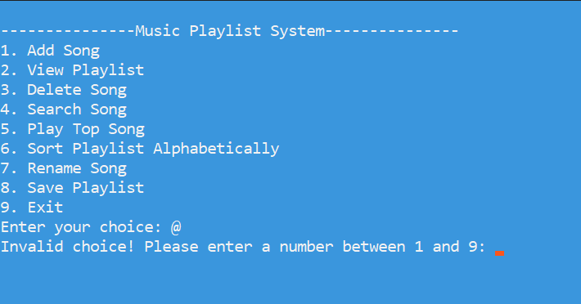

Module 2 — Adding a New Track (addSong Method)
Tests the booking action logic that screens against pre-existing duplications before appending onto the playlist.
TC# | Field | Valid Class | Invalid Class | Test Input | Expected Result
EP-A01 | Song details | Song does not exist | Duplicate Name & Artist | Name: Believer, Artist: Imagine Dragons (Already exists) | Output: "This song by the same artist already exists in the playlist!"
EP-A02 | Song details | Unique Name, same Artist | — | Name: Thunder, Artist: Imagine Dragons | Output: "Song added successfully!"
EP-A03 | Song details | Same Name, unique Artist | — | Name: Believer, Artist: Boyce Avenue | Output: "Song added successfully!"
EP-A04 | Song details | Brand new song data | — | Name: Shivers, Artist: Ed Sheeran | Output: "Song added successfully!"
EP-A05 | Song details | Empty or skipped entries | Handled by nested loop | "" (blank field) | Blocked by getValidInput loop
EP-A06 | Counter increment | System Counter state | — | Add any unique song | Node instantiated with songIdCounter++
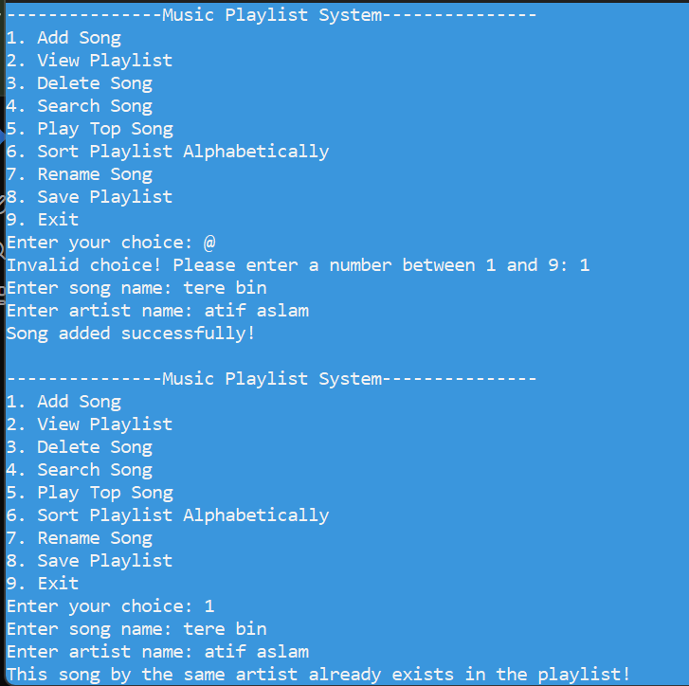

Module 3 — Text File Operations (loadFromFile / saveToFile Methods)
Tests file parsing configurations over the persistent playlist.txt storage vehicle.
TC# | Operation | Valid Class | Invalid Class | Test Input | Expected Result
EP-F01 | loadFromFile() | File exists with structured data | — | Standard playlist.txt file | List successfully structured into circular linked list nodes
EP-F02 | loadFromFile() | — | File does not exist | playlist.txt missing | Method returns immediately without breaking app execution
EP-F03 | loadFromFile() | — | Malformed line limits | ID read, but missing title/artist lines | Loops encounter EOF, stream breaks safely out of while loop
EP-F04 | saveToFile() | Output stream created successfully | — | Standard write path | Node fields mapped cleanly into matching output blocks
EP-F05 | saveToFile() | Active entries found | Empty list structure | Playlist contains no nodes (head == NULL) | File output processes nothing, loops safely avoided
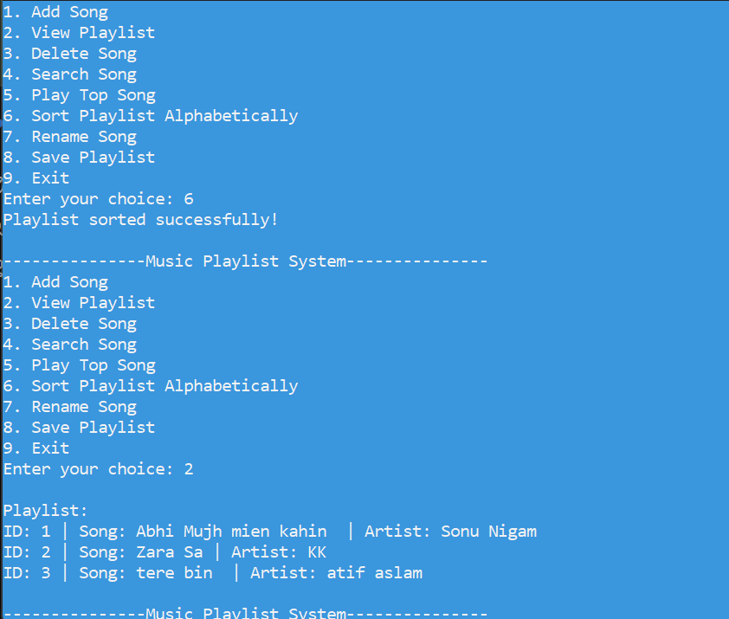

Module 4 — Selection Sort Sorting Logic (sortPlaylist Method)
Tests the alphabetical selection sorting routines across internal state tracking mechanics.
DOCX
TC# | State Layout | Valid Class | Invalid Class | Test Input | Expected Result
EP-S01 | Playlist State | Multiple unordered items | — | ["Abhi mujh ma Kahin ", "Tere bin ", "Zara sa"] | Re-arranged node fields: ["Abba", "Bohemian", "Zebra"]
EP-S02 | Playlist State | Already sorted configuration | — | ["Abhi mujh ma Kahin ", "Tere bin ", "Zara sa"] | Loop completes without executing internal field swaps
EP-S03 | Playlist State | — | No items found | head == NULL | Output: "Playlist is already sorted or empty!"
EP-S04 | Playlist State | — | Single item found | Only 1 song node | Output: "Playlist is already sorted or empty!"
EP-S05 | Capitalization | Uniform casing layout | — | ["blue", "Alpha"] | Sorted based on standard ASCII values ("Alpha" before "blue")
EP-S06 | Structural link check | Pointer tracking preserved | — | Perform full sort operation | Internal values swap successfully while pointers stay intact
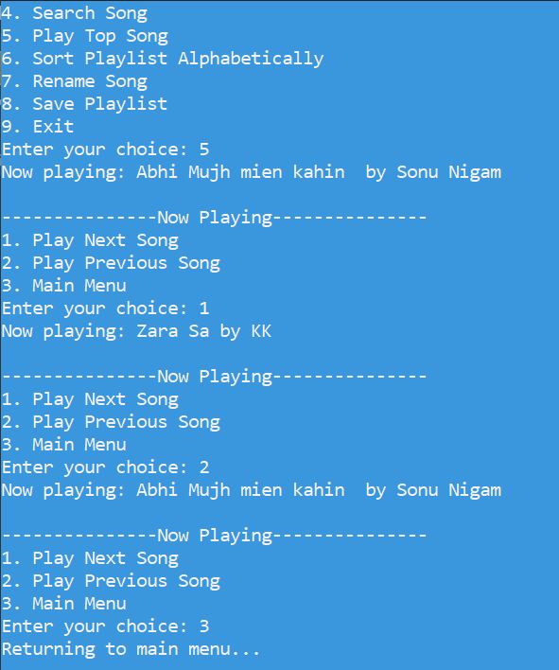

2.Boundary Value Analysis (BVA)
Boundary Value Analysis focuses on the boundaries of input domains or internal states, as faults are frequently found at the extreme edges of valid and invalid ranges.
Module 1 — Input Sanitization (getValidInput Length & Filtering)
This test focuses on character string limits and boundary conditions inside the parsing loops. Since string allocations inside standard cin streams handle varying characters, we inspect string length thresholds and single-character type boundaries.
TC# | Field/Target | Boundary Condition | Input Value | Expected Result
BVA-I01 | String Length | Minimum boundary ($B_{min}$) | "A" (1 Character) | Accepted successfully
BVA-I02 | String Length | Just below minimum ($B_{min-1}$) | "" (0 Characters/Empty) | Rejected, prompts re-entry loop
BVA-I03 | Character Map | Valid boundary character | "Track-1" (Includes hyphen -) | Accepted successfully
BVA-I04 | Character Map | Invalid boundary character | "Track_1" (Includes underscore _) | Rejected, prompts re-entry loop

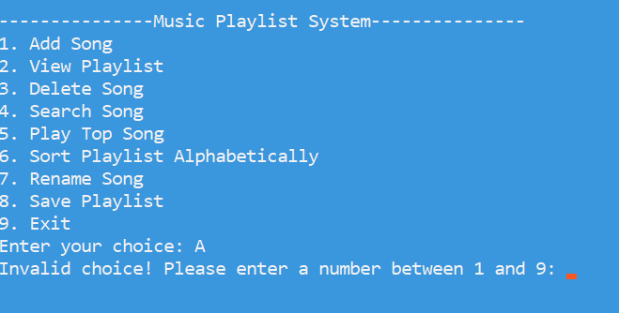

Module 2 — Adding a New Track (addSong Counter Tracking)
This boundary test checks the ID index tracking loops.
TC# | Field/Target | Boundary Condition | System Counter State | Expected Result
BVA-A01 | Node ID Index | System initialization boundary | songIdCounter == 1 | First song node created with ID: 1
BVA-A02 | Node ID Index | Consequent sequential index step | songIdCounter == 2 | Next song node created with ID: 2
BVA-A03 | Playlist State | Empty linked list state | Total tracks = 0 (head == NULL) | head and tail assigned to new node
BVA-A04 | Playlist State | Single to multiple nodes step | Total tracks = 1 (head == tail) | Links update, tail moves to new node

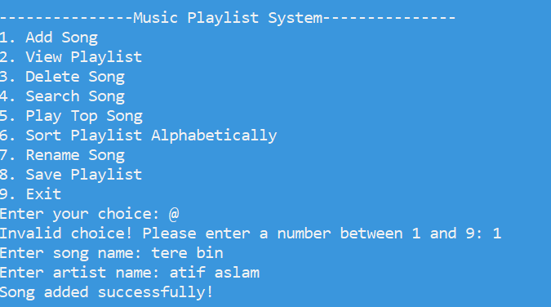

Module 3 — Text File Operations (loadFromFile Data Stream)
This monitors boundary issues encountered when parsing blocks from the file text system. It tracks the exact lines provided within playlist.txt.

TC# | Field/Target | Boundary Condition | File Contents Input | Expected Result
BVA-F01 | File Lines Block | Exact expected boundaries | 3 valid lines (ID, Name, Artist) | 1 song successfully parsed and linked
BVA-F02 | File Lines Block | Missing final attribute boundary | 2 lines (ID, Name only, EOF reached) | Evaluates !getline, breaks loop safely
BVA-F03 | File Lines Block | Single line boundary failure | 1 line (ID only, EOF reached) | Evaluates !getline, breaks loop safely
BVA-F04 | File State | Empty file condition | Completely empty playlist.txt file | while(getline) fails instantly, returns safely

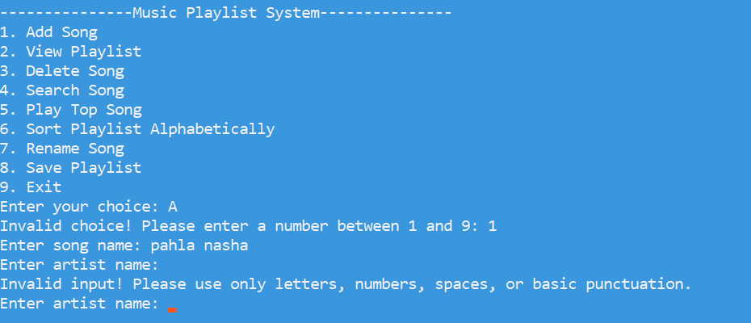

Module 4 — Selection Sort Logic (sortPlaylist Element Counts)
This monitors edge cases for execution conditions of the selection sort algorithm based on list sizing boundaries.
TC# | Field/Target | Boundary Condition | Total Track Nodes | Expected Result
BVA-S01 | Node Count Sizing | Edge boundary: No tracks | 0 Nodes (head == NULL) | Prints "Playlist is already sorted..."
BVA-S02 | Node Count Sizing | Edge boundary: One track | 1 Node (head->next == head) | Prints "Playlist is already sorted..."
BVA-S03 | Node Count Sizing | Minimum sorting boundary | 2 Nodes | Enters nested loop, executes exactly 1 comparison pass
BVA-S04 | Loop Completion | Tail element boundary check | current == tail | Outer loop breaks successfully, stopping sorting passes

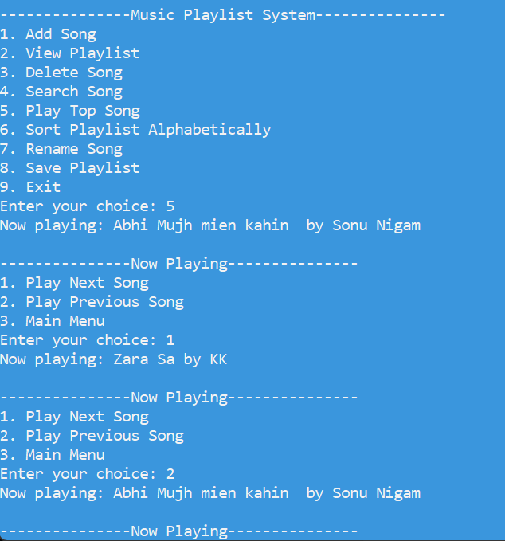

3. Decision Table Testing
Decision Tables model combinations of conditions (causes) and their corresponding actions (effects). Each column represents a rule—a unique combination of conditions with its resulting action.
Module 1 — Input Sanitization (getValidInput Method) Decision Table
Description: Tests the the character whitelist conditions checking string contents during text fields collection loop processes.

- Description: Tests the character whitelist conditions checking string contents during text fields collection loop processes.
Condition / Action | Rule 1 | Rule 2 | Rule 3 | Rule 4
String is completely empty (input.empty())? | Y | N | N | N
String contains alphanumeric values or spaces? | — | Y | N | Y
String contains non-whitelist punctuation symbols? | — | N | Y | Y
ACTION: Accept input and return string safely | ✗ | ✓ | ✗ | ✗
ACTION: Print "Invalid input! Please use only letters..." | ✓ | ✗ | ✓ | ✓
ACTION: Keep user stuck inside while(true) input loop | ✓ | ✗ | ✓ | ✓

Module 2 — Track Creation and Duplication Check (addSong Method) Decision Table
- Description: Evaluates duplicate protection paths when linking nodes based on tracking historical items within the playlist list space.

Condition / Action | Rule 1 | Rule 2 | Rule 3 | Rule 4
Playlist list structure contains existing nodes (head != NULL)? | N | Y | Y | Y
Track Name matches an existing Node? | — | Y | Y | N
Artist Name matches that exact same node? | — | Y | N | Y
ACTION: Instantiate new Song Node using songIdCounter++ | ✓ | ✗ | ✓ | ✓
ACTION: Append to circular tail and connect links to head | ✓ | ✗ | ✓ | ✓
ACTION: Print "This song by the same artist already exists..." | ✗ | ✓ | ✗ | ✗

Module 3 — Text File Storage (loadFromFile / saveToFile Methods) Decision Table
- Description: Maps conditions of file presence, data correctness, and list state to parsing variations over playlist.txt.

Condition / Action | Rule 1 | Rule 2 | Rule 3 | Rule 4
Target configuration file playlist.txt exists on disk? | N | Y | Y | —
Stream can securely map out file structure lines safely? | — | Y | N | —
Main runtime playlist contains track records (head != NULL)? | — | — | — | N
ACTION: Gracefully exit loadFromFile() early (No crash) | ✓ | ✗ | ✗ | ✗
ACTION: Construct node sequence using loaded metadata blocks | ✗ | ✓ | ✗ | ✗
ACTION: Abruptly break out of load loop while stream fails | ✗ | ✗ | ✓ | ✗
ACTION: saveToFile() finishes without processing write steps | ✗ | ✗ | ✗ | ✓

Module 4 — Selection Sort Sorting System (sortPlaylist Method) Decision Table
- Description: Monitors execution variables of selection sorting passes across internal circular linked list states.

Condition / Action | Rule 1 | Rule 2 | Rule 3 | Rule 4
Playlist structure has 0 or 1 item records (!head || !head->next)? | Y | N | N | N
Outer cursor pointer reaches boundary limits (current == tail)? | — | Y | N | N
Inner search loop flags smaller string item value (temp->name < min->name)? | — | — | Y | N
ACTION: Print "Playlist is already sorted or empty!" | ✓ | ✗ | ✗ | ✗
ACTION: Terminate parent sorting loop process | ✗ | ✓ | ✗ | ✗
ACTION: Update tracking variable (min = temp) | ✗ | ✗ | ✓ | ✗
ACTION: Move tracking node pointers forward safely | ✗ | ✗ | ✗ | ✓

4.Cause-Effect Mapping & Test Case Matrix
This table defines how combinations of causes structurally map to functional execution effects across your system modules.
TC# | Monitored Module | Present Cause(s) | Resulting Effect(s) | Concrete Test Scenario Description | Expected Result
CE-01 | Main Application Menu | C1 | E1 | Select choice option 9 from the main console menu layout and press Enter. | Prints "Exiting program. Goodbye!" and terminates execution safely.
CE-02 | Main Application Menu | C2 | E2 | Input an out-of-range value (like 15) or an invalid string (like "abc") into the main interface prompt. | Stream error flags reset seamlessly, ignoring bad inputs, and re-renders the main menu.
CE-03 | Track Deletion Module | C3 | E3 | Select main option 3 and input an unregistered track name/artist pairing. | Prints "Song not found!" and preserves all current node linkages.
CE-04 | Track Deletion Module | C4 | E4 | Add exactly one song to a blank playlist, then trigger option 3 to delete that precise track. | Successfully prints "Song deleted successfully!" and resets head and tail pointers to NULL.
CE-05 | Media Playback System | C5 | E5 | Launch the binary executable file without any text database file records available, and press choice option 5. | Output explicitly triggers structural warning strings: "Playlist is empty!".
CE-06 | Track Renaming Module | C6 | E6 | Choose menu option 7, select an existing song record, and input a name matching another saved track. | Operation halts safely, writing: "A song with the new name already exists...".

5. State Transition Testing
Module 1 — Input Sanitization (getValidInput Loop States)
- Description: Monitors state flags inside the string input reading functions as they handle keyboard stream errors, length validation, and characters whitelisting loops.
TC# | Current State | Event | Next State | Expected Output
ST-IS01 | Input Idle | Enter valid non-empty string | Input Accepted | Closes input processing window and returns text string safely to the program.
ST-IS02 | Input Idle | Press Enter without entering text | Validation Error | Prints error message: "Invalid input! Please use only letters..."
ST-IS03 | Validation Error | Dismiss error / provide valid string | Input Accepted | Bypasses loop constraints, returns newly verified data cleanly.
ST-IS04 | Input Idle | Input unauthorized symbols (_, @) | Validation Error | Rejects loop escape sequence, holds user trapped in the loop.

Module 2 — Adding a New Track (addSong Duplicate Detection)
- Description: Focuses on list memory states and linking paths when attempting to instantiate and append new items into the playlist list structure.
TC# | Current State | Event | Next State | Expected Output
ST-AS01 | Empty List (head == NULL) | Add new unique song record | Single Node List | Instantiates first element node, maps head and tail pointers to its address.
ST-AS02 | Single Node List | Add second unique song record | Multiple Node List | Adjusts circular references, linking tail->next to the new item node.
ST-AS03 | Multiple Node List | Add song with identical Name and Artist | Duplicate Error | Rejects node creation, outputs: "This song by the same artist already exists..."
ST-AS04 | Duplicate Error | Return back to operations menu choice | Main Menu Prompt | Preserves all pre-existing node pointers intact without memory leaks.

Module 3 — Text File Operations (loadFromFile / saveToFile Stream Status)
- Description: Maps stream handling behaviors as the application parses data from playlist.txt or dumps runtime variables onto the disk storage asset.

TC# | Current State | Event | Next State | Expected Output
ST-FO01 | Uninitialized Storage State | Run application boot (File found) | Active Parsing Mode | Seamlessly connects ifstream stream structure line arrays to process inputs.
ST-FO02 | Active Parsing Mode | File hits EOF marker cleanly | Data Loaded Ready | Closes file stream, returns to main console menu interface loop.
ST-FO03 | Active Parsing Mode | Line item attributes are missing | Stream Failure Halt | Triggers loop validation breakout mechanism safely without application crash.
ST-FO04 | Data Loaded Ready | Select Main Option 8 (saveToFile) | Database File Updated | Flushes active list elements down to plain text blocks, closing out files safely.

Module 4 — Selection Sort Logic (sortPlaylist Execution Passes)
- Description: Evaluates state variables as the pointer loop passes execute comparison passes to reorganize node data alphabetically.
TC# | Current State | Event | Next State | Expected Output
ST-SS01 | Unsorted Multiple Nodes | Select Menu Option 6 | Active Sorting Pass | Validates list sizing constraints and initializes outer index node traversal trackers.
ST-SS02 | Active Sorting Pass | String comparison (temp->name < min->name) | Tracking Variable Updated | Swaps reference tracking variables, designating current location as temporary minimum.
ST-SS03 | Active Sorting Pass | Outer loop cursor tracking hits tail boundary | Sorting Process Finalized | Finalizes all data adjustments, prints statement: "Playlist sorted successfully!"
ST-SS04 | Unsorted List ($\le 1$ Element Node) | Select Menu Option 6 | Main Menu Prompt | Early-exit safety check triggers, printing: "Playlist is already sorted or empty!"

